
RAMAIAH
INSTITUTE OF TECHNOLOGY
USN | 1 | M | S

(Autonomous Institute, Affiliated to VTU)
Bangalore – 560 054

MAKEUP EXAMINATIONS – MAY/JUNE 2017

Course & Branch | : | B.E: Electrical & Electronics Engineering | Semester | : | VI
Subject | : | Linear Integrated Circuits | Max. Marks | : | 100
Subject Code | : | EE604 | Duration | : | 3 Hrs

Instructions to the Candidates:
- Answer one full question from each unit.
- Use of standard resistor and capacitor values list is permitted.
- Suitable assume the missing data if any.

 |  | UNIT- I
1. | a) | Draw the equivalent circuit and ideal voltage transfer curve of an op-amp. | CO1 | (04)
 | b) | A direct coupled non inverting amplifier with a + 15V supply is to produce maximum possible output voltage and is to have a voltage gain of 40dB. The input voltage is to be 50 mV a.c. Using 741 Op-Amp, design a suitable circuit. Ensure that the circuit is suitably compensated for I_{B}R_{B} drop. Draw the circuit diagram with the component values mentioned on it. Also calculate the input and the output impedance for the circuit designed (From 741 data sheet: typical open loop gain = 200000; typical open loop input impedance = 2 MΩ; typical open loop output impedance = 75Ω). | CO5 | (10)
 | c) | Explain how slew rate of an op-amp can introduce distortion in the output waveform. | CO1 | (06)
2. | a) | Draw the block diagram of an op-amp and explain the functions of each block | CO2 | (04)
 | b) | Define the following:  i) Input offset voltage ii) Output offset voltage iii) Input offset current and hence suggest a method to nullify the offset effect in a 741 op-amp. | CO1 | (08)
 | c) | A 1 K Ω load is to have 2V developed across it from a 15V source. Design  i) A potential divider circuit such that V_{L} is derived directly from V_{CC} (Fig 2.(c)(i)).  ii) A voltage follower is connected between the potential divider and R_{L} (fig. 2.(c)(ii)). Calculate load voltage variation in each case, when the load resistance varies by -10%. Use a 741 Op-Amp.  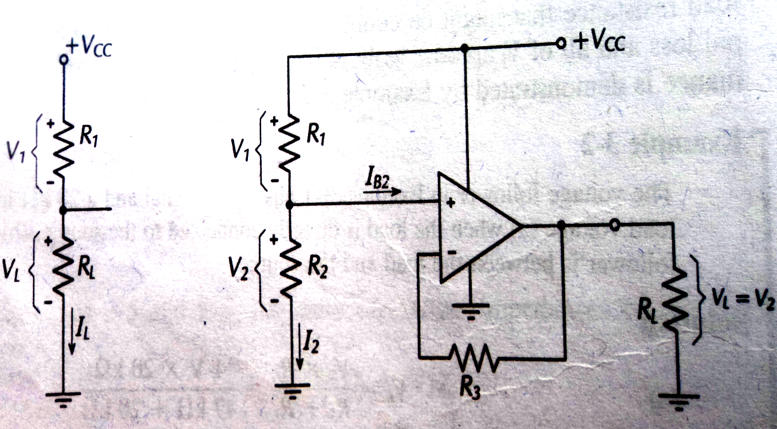  2.(c)(i) 2.c(ii) | CO5 | (08)
 |  | UNIT- II
3. | a) | A capacitor coupled non inverting amplifier is to have a closed loop voltage gain of 90 and V_{o}=3V. The load resistance is 10KΩ and lower cutoff frequency is to be 70Hz. Design a suitable circuit using BIFET opamp. Draw the circuit with designed component values. | CO2 | (07)
 | b) | Draw the circuit of ahigh input impedance full wave precision rectifier and explain. Draw the various waveforms. | CO2 | (08)
 | c) | Explain the working of a peak clipper with a circuit diagram. | CO2 | (05)
4. | a) | Design a capacitor coupled inverting amplifier to have a signal frequency range from 100Hz to 2KHz. The voltage gain is to be 50 and output voltage amplitude is to be 2V. The load resistance is 500Ω. Draw the circuit with designed component values. | CO2 | (10)
 | b) | Explain the working of a sample and hold circuit with a circuit diagram. Draw the various waveforms. What is acquisition time and how it is calculated? | CO2 | (10)
 |  | UNIT- III
5. | a) | Design a wide band pass filter with f_{L} = 200 Hz and f_{H} = 15 KHz with a pass band gain of 4. Calculate the value of Q for the filter designed. Draw the circuit diagram with component values mentioned on it | CO5 | (10)
 | b) | With a neat sketch explain the working of phase shift oscillator. Write the steps involved in designing the filter. | CO2 | (10)
6. | a) | Design the triangular wave generator so that frequency of oscillation f₀ = 1.7 KHz and V_{0(P-P)} = 7V. Use 741 op-Amp with a supply voltage of + 15V. Draw the circuit diagram with component values mentioned on the circuit. Also sketch the expected waveform | CO5 | (10)
 | b) | (i) Design a first order high pass filter to have a cut off frequency of 12 KHz with a pass band gain of 4. Draw the circuit diagram with component values on it.  (ii) On a semi log sheet, plot the theoretical frequency response curve for the filter designed in (i).  (iii) Using frequency scaling technique, modify the filter designed in (i) to have a new cutoff frequency of 20 KHz. | CO5 | (10)
 |  | UNIT- IV
7. | a) | A battery charger control circuit is to be designed to monitor the voltage level of a 12V battery. When the battery’s voltage drops below 10.5V, the battery should be connected to the charger. When the battery voltage reaches 13.5V, it should be disconnected from the charger. The reference voltage is to be -15V. Assume + V_{sat} = + 13V. Design a suitable circuit. Sketch the complete circuit with component values mentioned on it. | CO3 | (10)
 | b) | Discuss the effect of load capacitance on op-amp circuit stability. Write the equation to determine the value of load capacitance that might produce circuit instability. Also discuss the methods of compensating for load capacitance effects. | CO3 | (10)
8. | a) | Explain why a low gain amplifier using an operational amplifier is more likely to be unstable than a high gain circuit. | CO3 | (05)
 | b) | Discuss over compensation and explain its effects. | CO2 | (05)
 | c) | Design an inverting Schmitt trigger with V_{UT} = 5V and V_{LT} = 2V. Use 741 Op-amp with a Supply voltage of + 15V. Draw the circuit with component values mentioned on it. Also draw the expected input and output waveform and Plot the hysteresis curve for the circuit designed. | CO3 | (10)
 |  | UNIT- V
9. | a) | Draw the circuit of a current amplifier whose current gain is independent of load resistance and explain. | CO2 | (06)
 | b) | With a diagram and waveforms explain the operation of timer IC 555 as an astable multivibrator. Derive an expression for period T. | CO4 | (10)
 | c) | Mention the applications of PLL. | CO4 | (04)
10. | a) | With circuit diagram and waveforms explain the working of a practical differentiating circuit. | CO2 | (06)
 | b) | Using 7805C voltage regulator, design a current source that will deliver a 0.25A current to a 48Ω, 10W load. | CO4 | (05)
 | c) | Draw the functional diagram of 555 timer and explain. | CO4 | (09)

****************

